**How to start a free VM in your cloud account**

*Since working with VM in GCP was not working, I have created an account in Azure*

Step 1: Create a free account in Azure

Step 2: Go to the Azure portal and select Create a resource.

Step 3: Select create in the Virtual machine

Step 4: Configure basic Settings:

* Resource Group: Create a new resource group or select an existing one.
* Virtual Machine Name: Enter a name for the VM.
* Region: Choose the region.
* Image: Select "Ubuntu Server 20.04 LTS" or another free tier image. Some Windows Server images might have free tiers as well.
* Size: Click B1s VM size since it’s a common free tier option.
* Authentication Type: Choose "SSH public key"
* Inbound Port Rules: Select "Allow selected ports" and choose "SSH (22)" for Linux

Step 5: Configure Additional Settings:

* Disks: Stick with the default settings, which are often sufficient for a free VM.
* Networking: Configure the network settings if necessary.
* Management, Monitoring, and Advanced Settings: use the defaults.

Step 6: Review and Create:

* Review your configurations.
* Click "Create" to deploy your VM.

Step 7: Select Review and create

Step 8: Download private ssh key

Step 9: Go to the create vm

Step 10: Select network settings and then select create inbound port rule

Step 11: Change the destination port ranges as * and protocol as ICMPv4.

**Try pinging your VM from your Kali linux**

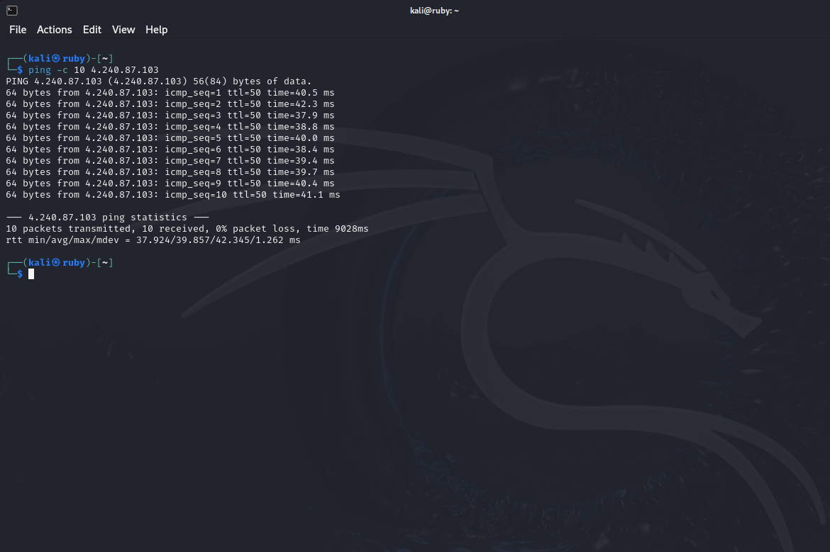

**Login to your VM via SSH, run the ip a command and take a screenshot of the result**

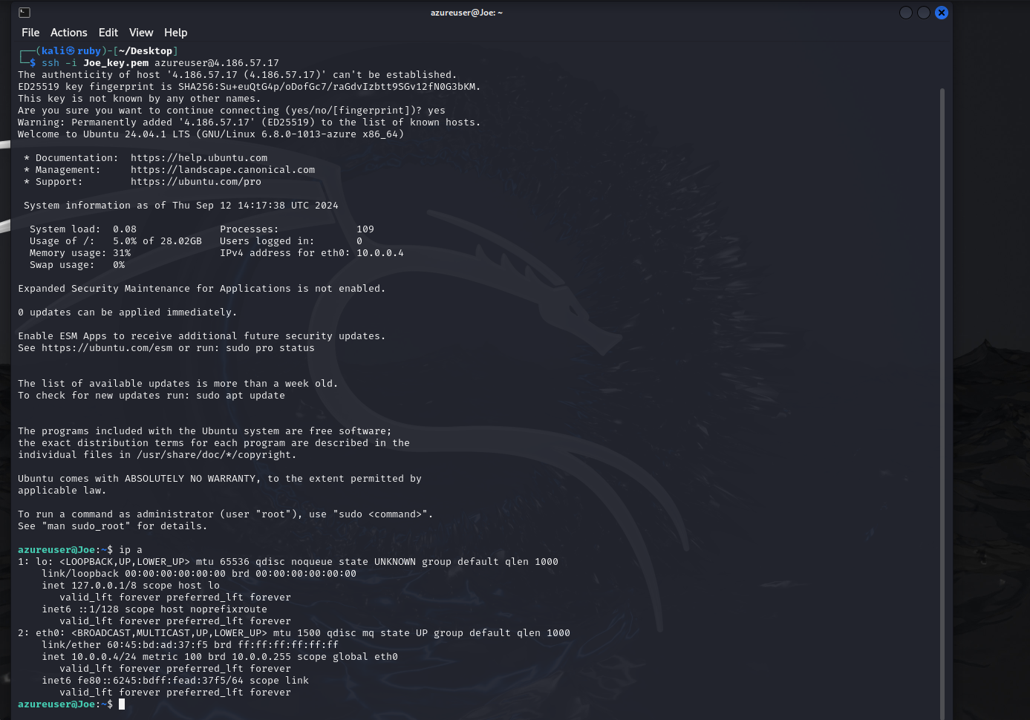

**Find your public IP and try pinging your public IP from cloud VM.**

